S. Bösch, N. Eckhart, R. Emberger and P. Meier

Tower Hopscotch

Project Design



Table of Contents

1. Project Management 3

1.1. Current stand 3

1.2. Review Iteration #4 3

1.3. Time Comparison 3

1.4. Risk List 4

2. Architecture 5

2.1. First Package Architecture Concept 5

2.2. Programming Language 5

3. Class Diagram 6

4. Class Responsibilities 7

5. Interaction Diagram 8

6. Glossary 9

7. GUI-Design 10

# Project Management

|  |  |
| --- | --- |
| Current Iteration | Iteration #5 [Construction Phase]  20. November 2017 – 01. December 2017 |
| Previous Iteration | **Iteration #4 [Elaboration Phase]**  06. November 2017 – 17. November 2017 |

## Current stand

With the completion of the fourth iteration, the project now enters the construction phase. All design related parts have been conceptually planned out and summarized in this document. We have already begun with developing some of the basic features such as the game class and loop, the map and layer concepts.

## Review Iteration #4

|  |  |  |  |  |  |
| --- | --- | --- | --- | --- | --- |
| Iteration #4 | | | | | |
| **Elaboration Phase** | | 06.11.2017 | | 17.11.2017 | |
| **No.** | **Task** | **Assignee** | **Expected Time [h]** | | **Effective Time [h]** |
| 1 | Project Management | N. Eckhart | 4hrs | | 3.5hrs |
| 2 | Compile all Artifacts from Iteration #3 into design document. | P. Meier | 6hrs | | 8hrs |
| 3 | Add additional descriptions required for design document diagrams. | S. Bösch | 6hrs | | 5hrs |
| 4 | Define UI Prototype parameters for implementation in the next iteration. | R. Emberger | 8hrs | | 8hrs |
| 5 | Create game class with game loop. | N. Eckhart | 5hrs | | 3hrs |
| 6 | Create map class that can load a simplified map from a file with only path and non-path tiles. (Only one layer.) | P. Meier, S. Bösch | 12hrs | | 9hrs |
| 7 | Update Glossary as needed | Team | 2hrs | | - |

## Time Comparison

We lost a bit of time in the third iteration due to our design class diagram being more time demanding than expected. We were able to compensate for that in iteration #4 so our effective time expenditures ended up being in acceptable ranges.

## Risk List

Our risk has not undergone any major changes, however since starting coding we have decided that the likelihood of the project complexity exceeding our expectations is fairly low as we now have a general idea of how to implement these features. We have accordingly also lowered the potential impact it might have on our project.

We have also decided on lowering the potential impact that the temporary loss of a developer might have. We did this because we have all features planned out and thus everybody is able to do any task.

|  |  |  |  |
| --- | --- | --- | --- |
| Risk | Counter Measure | Likelihood of occurrence | Impact on Project |
| Code becomes hard to understand or maintain. | Follow clean code guidelines and have code reviews. | Low | Medium |
| Project complexity exceeding expectations resulting in increased time consumption. | Thorough analysis and detailed iteration planning. | Low | Medium |
| Lacking technical knowledge of one or more team members in a certain area resulting in increased time consumption. | Regular sharing of gained knowledge and assign tasks based on the developer’s skills. | Medium | Low |
| Loss of one developer for an extended period due to unexpected circumstances such as illness. | None | Low | Medium |

*Risk list as of the 18th of November 2017*

# Architecture

Tower Hopscotch is going to be a standalone desktop application. Data persistence required for features such as custom maps will be accomplished with text files that the program reads from and writes to on the file system. The user interface will be two-dimensional in the game’s first iteration.

## First Package Architecture Concept

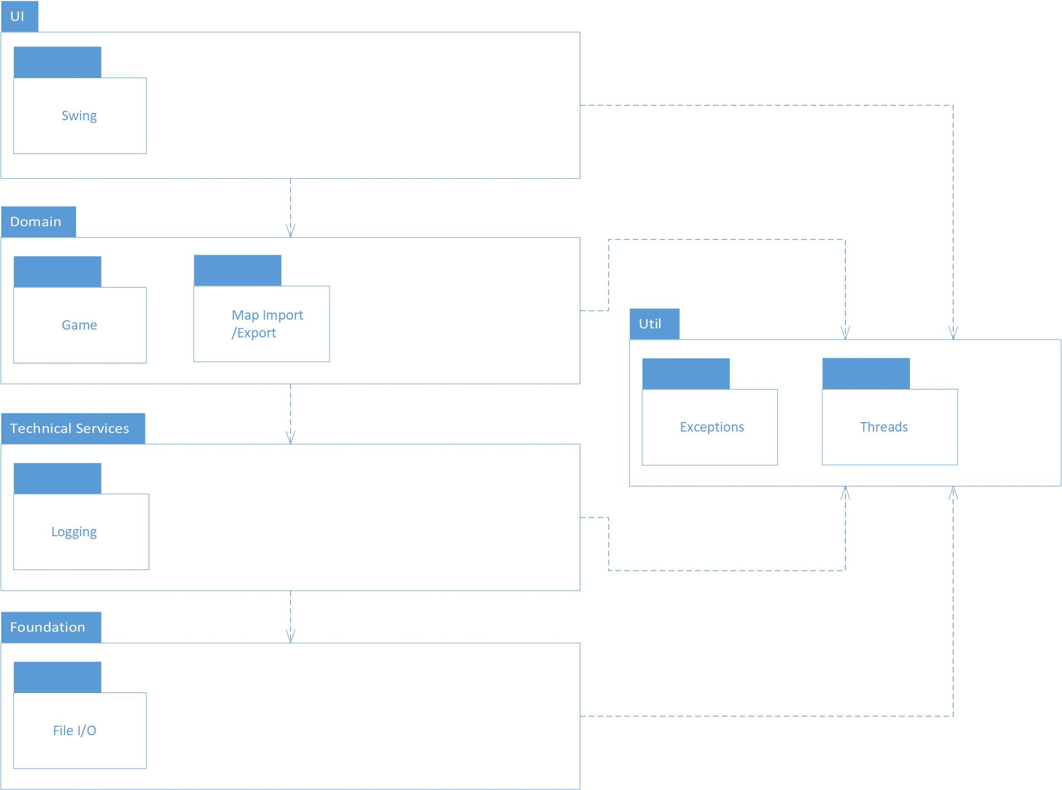

# Design Class Diagram

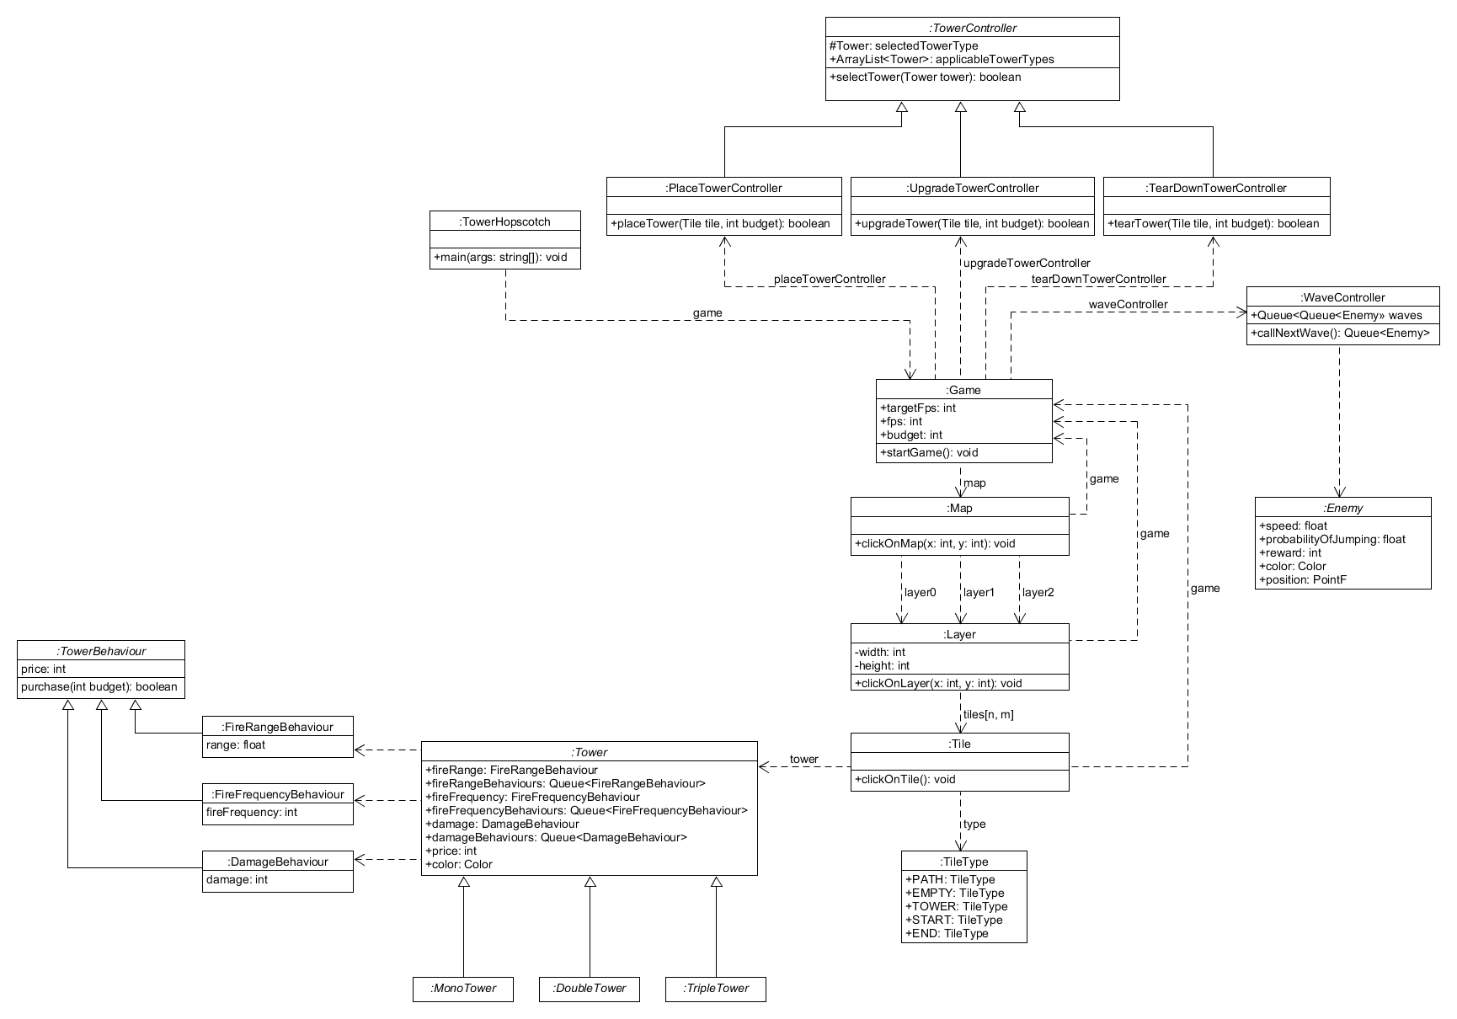

# Class Responsibilities

# Interaction Diagram

# Glossary

|  |  |
| --- | --- |
| Term | Definition |
| Fortress | The players central structure, the defense of which is the games main objective. Also referred to as Castle. |
| Tower | Any of a variety of defensive or offensive building created by the player to hinder or destroy incoming enemies. |
| Wave | A wave refers to a group of enemies. A game encompasses multiple waves that need to be defeated. |
| Layer | Each map has three layers that simultaneously spawn incoming enemies that may jump between these layers. |
| Treasury (Budget) | The amount of gold the player has at any given time. Also referred to as budget. |
| Gold | The currency used in Tower Hopscotch. Gold is obtained by destroying enemies and can be spent on towers and upgrades. |
| Hit points | Hit points refer to the amount of health an enemy or the players fortress has. |

# GUI-Design

## In-Game Layer Positioning

Much of the screen will be taken up by the three layers. The layers themselves will use different textures to make each of them distinct from the others. The paths as well will vary from layer to layer. The game window will be laid out in a landscape format to fit in all three layers horizontally.

## In-Game User Menu

The bottom part of the game window is taken up by the in-game user menu. It contains information relevant to the player as well as buttons for building and upgrading towers.

On the bottom left there are buttons for each of the towers the player can build. Once clicked, the player can hover his mouse over any part of the map, and there will be a square overlaid at the mouse pointer. This square is green if the tower may be built at that position. If the player does not have the gold, there is already a tower there or he is hovering above a path tile, then the square is red.

If the square is green, then the player can use another left click to build the tower at his mouse’s current position. He or she may also at any time cancel his build action by right clicking. Next to the tower buttons, there are two none-interactive labels that show the players remaining hit points as well as his accumulated gold.

On the bottom right, there are two large buttons that are both not clickable by default. The call next wave button gets enabled once all enemies of the current wave have been destroyed. Clicking on it prompts the next wave to begin. The tower upgrade button gets enabled when the player has selected a tower by left clicking it on the map. He also has to have enough gold to purchase the upgrade. The cost of an upgrade is displayed on the button itself when a tower is selected. When purchased, the tower receives the upgrades effects and the cost is deducted from the players treasury.

